Ryan Iusi

**Feature #1 (Contact Us)**

The Contact Us page will function as a way for public users to discern the location, and important contact information regarding the hospital. Email addresses and phone numbers will be displayed that users will be able to use in order to contact the Hospital. A map will also be displayed showing the location of the hospital, and input boxes will be made available for users to enter their personal address information which will update the map with directions from that address.

An Administration page will make it possible for an Admin to update, add and delete Contact Information whenever it may be required.

|  |  |
| --- | --- |
| Contact ID | Numeric PK |
| Contact_fname | Text 100 characters |
| Contact_lname | Text 100 characters |
| Contact_email | Text 100 characters |
| Contact_phone | Numeric |

**Data Flow Models**

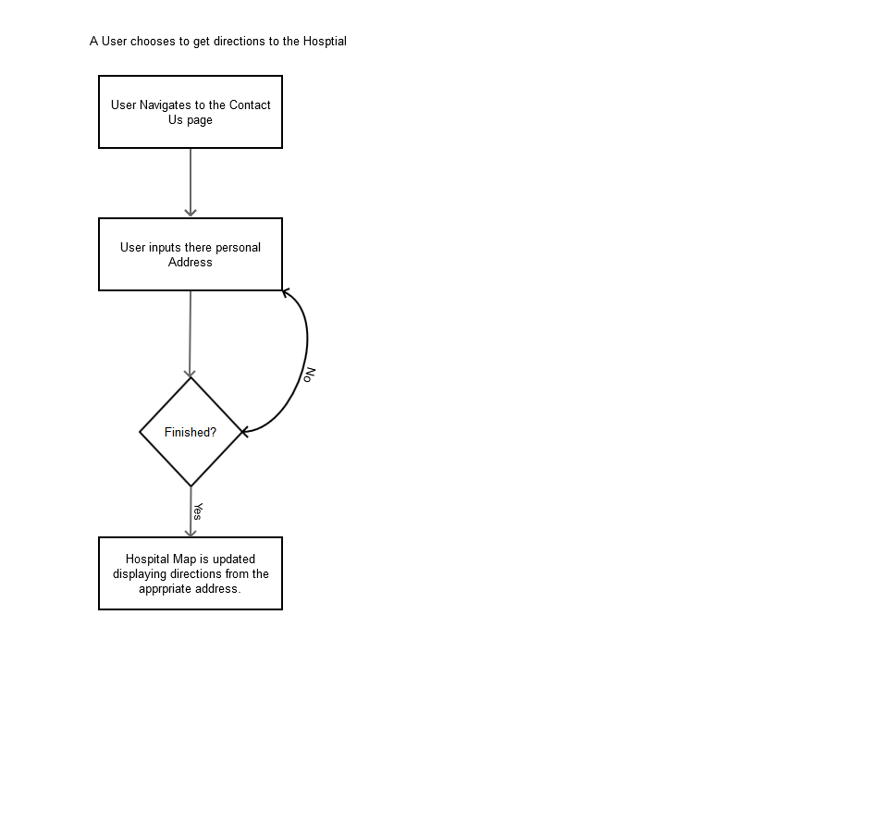

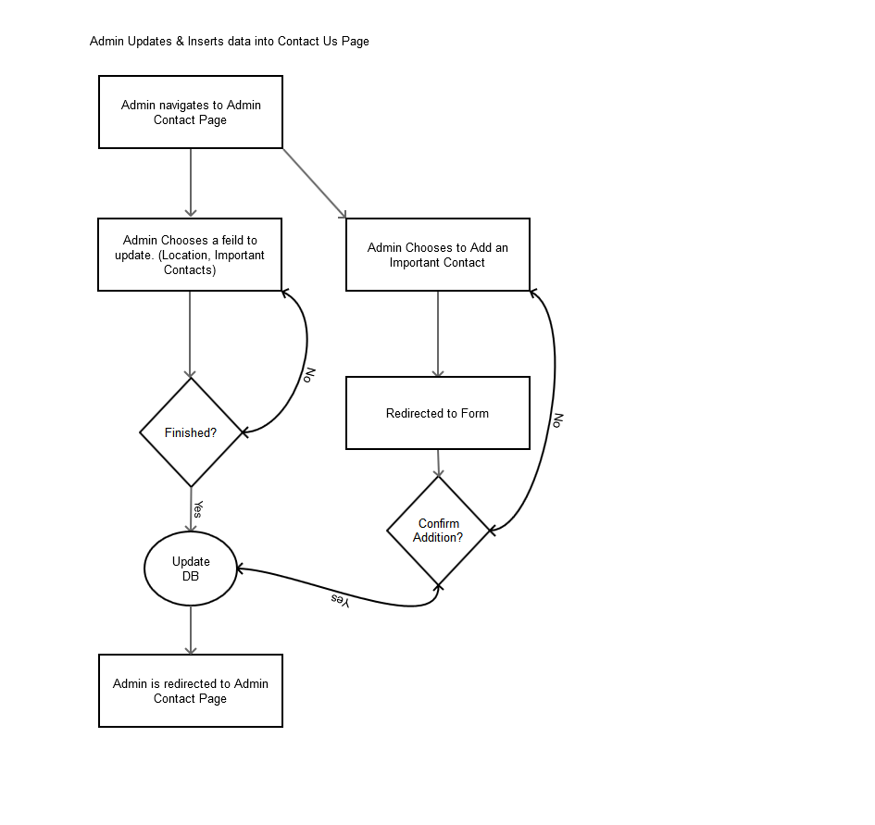

**Wireframes**

Public Page

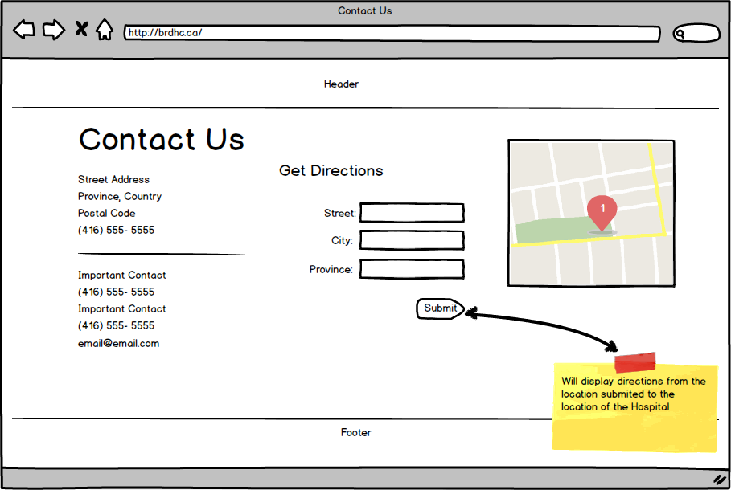

Admin Pages

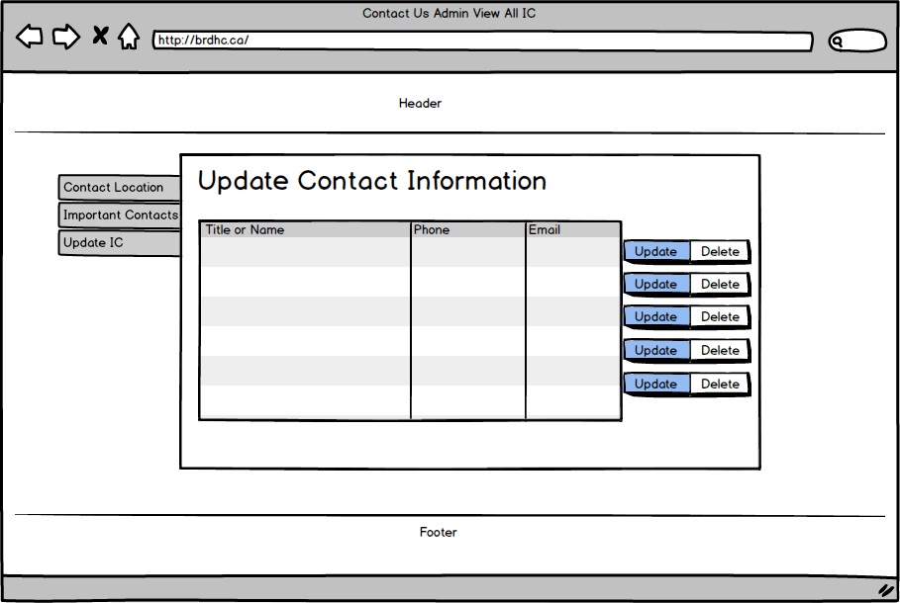

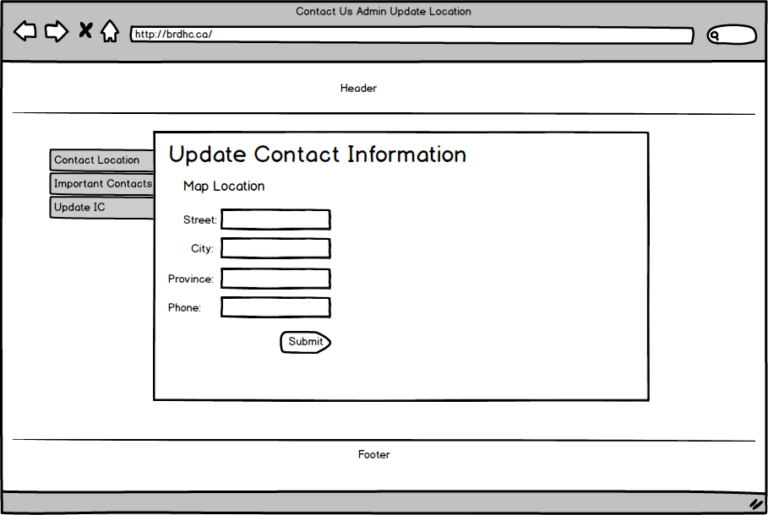

**Feature #2 (Events Calendar)**

This feature will allow public users to see upcoming community events, as added by the community. Users with the appropriate login roles and Admins will be able to add and update events to the Events Calendar for the community to see. This will be useful for promoting public events, public outreach programs, and community groups and associations.

An Administration backend will allow appropriate users to manage, delete and create new events to be displays on the Calendar. Only users with the right permissions will have access to this feature, as this will prevent abusive and non-relevant events to be posted to the calendar.

|  |  |
| --- | --- |
| Event ID | Numeric PK |
| Event User | Text 100 characters FK |
| Description | Text 500 characters |
| Event Title | Text 100 characters |
| Stat Date | Date |
| End Date | Date |

**Data Flow Models**

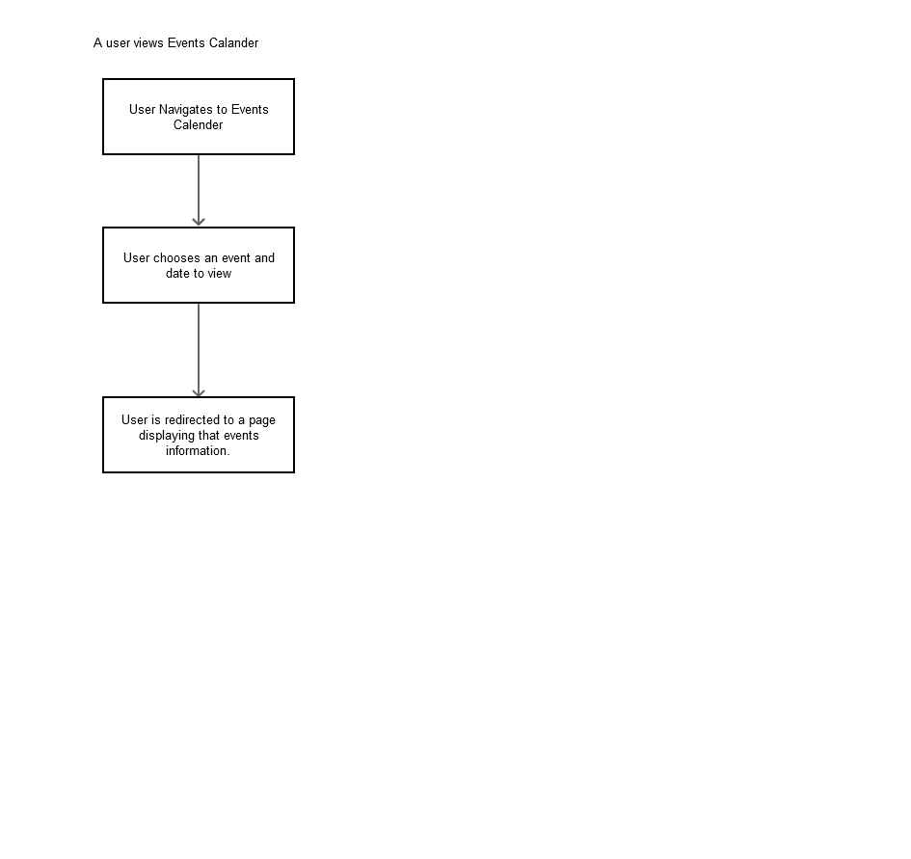

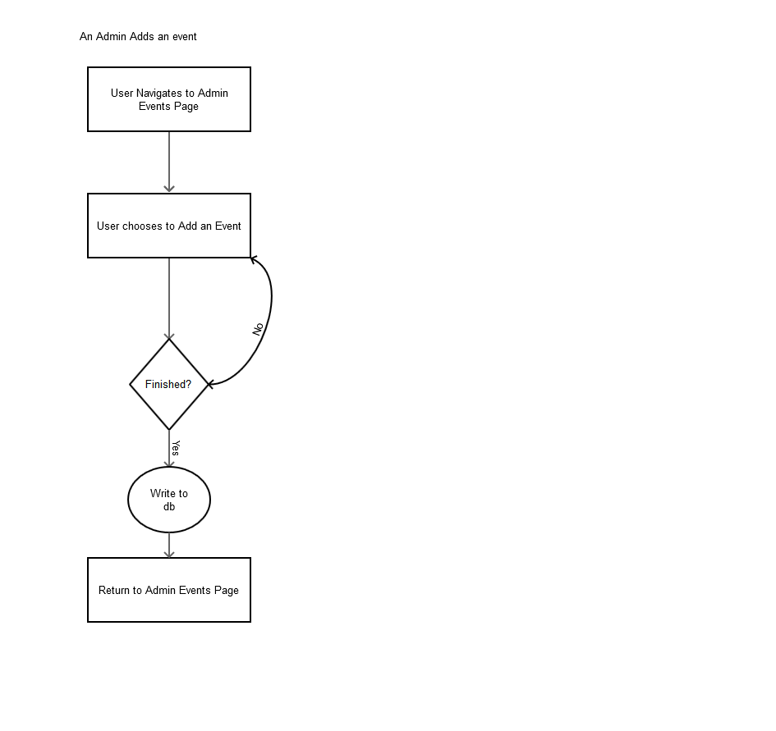

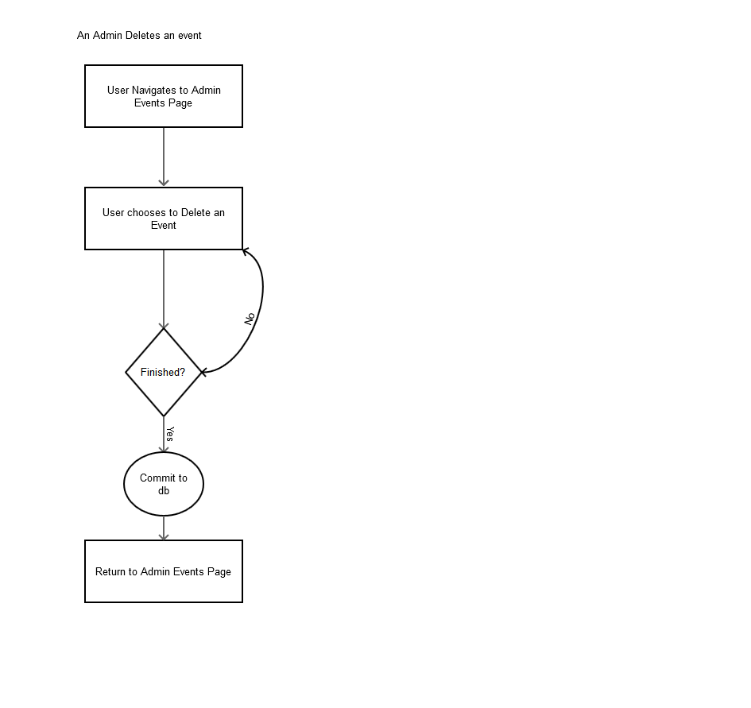

**Wireframes**

Public Side

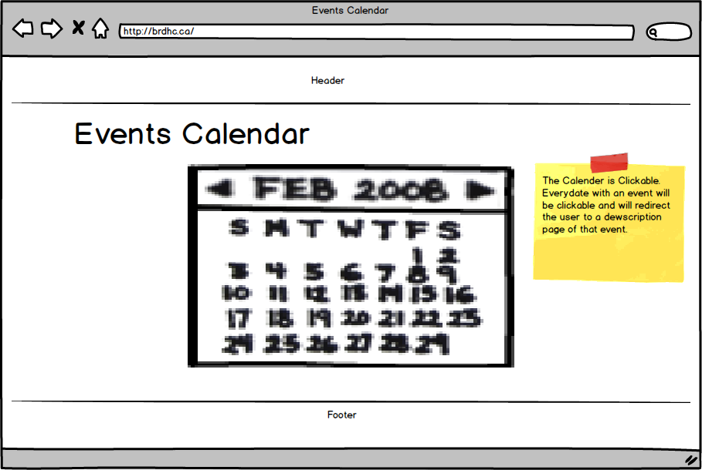

Admin Side

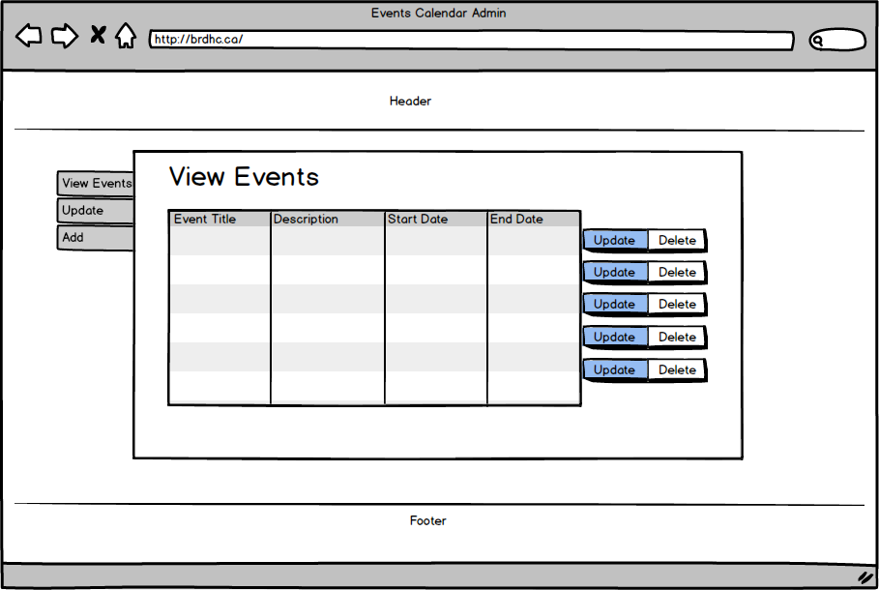

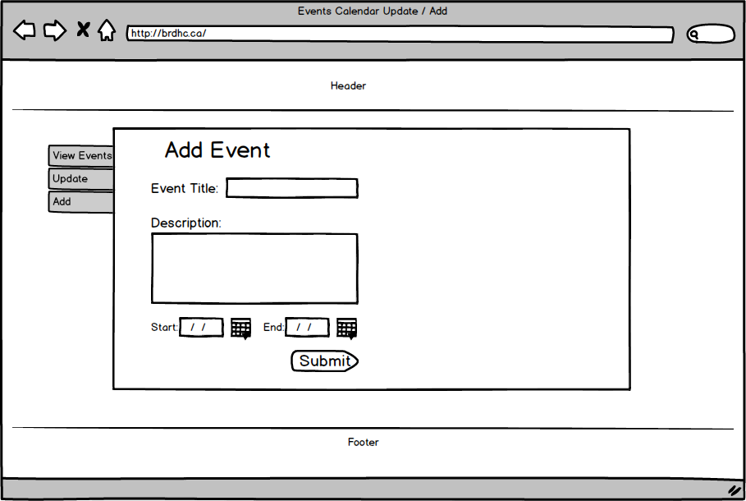

**Feature #3 (Careers)**

This feature will display career opportunities at the hospital. It will allow public users to view these opportunities, as well as allow them to apply and upload resumes and cover letters to be considered for that position.

An administrative backend will allow admins to update, add and delete career opportunities whenever appropriate. This backend will also organize all the applicants to these careers, and allow the admin to easily navigate through these applicants and consider them for the position they have applied for.

|  |  |
| --- | --- |
| Applicant ID | Numeric PK |
| First Name | Text 100 characters |
| Last Name | Text 100 characters |
| Career ID | Numeric FK |
| Resume | Document |
| Cover letter | Document |
| About Me | Text 500 characters |

|  |  |
| --- | --- |
| Career ID | Numeric PK |
| Career Title | Text 100 characters |
| Description | Text 500 characters |
| Start Date | Date |

**Data Flow Models**

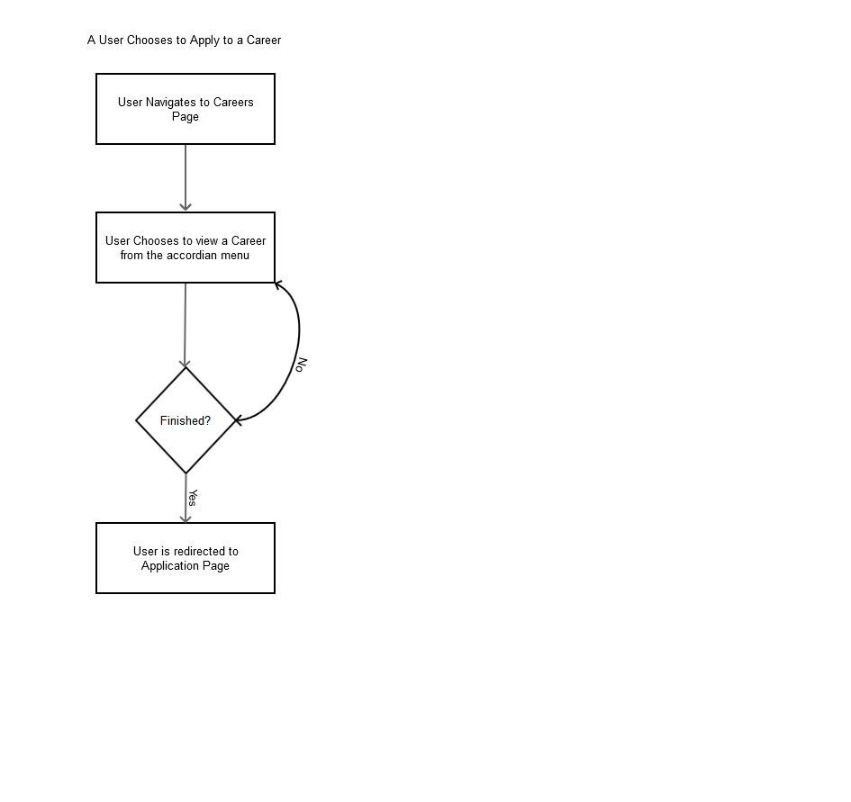

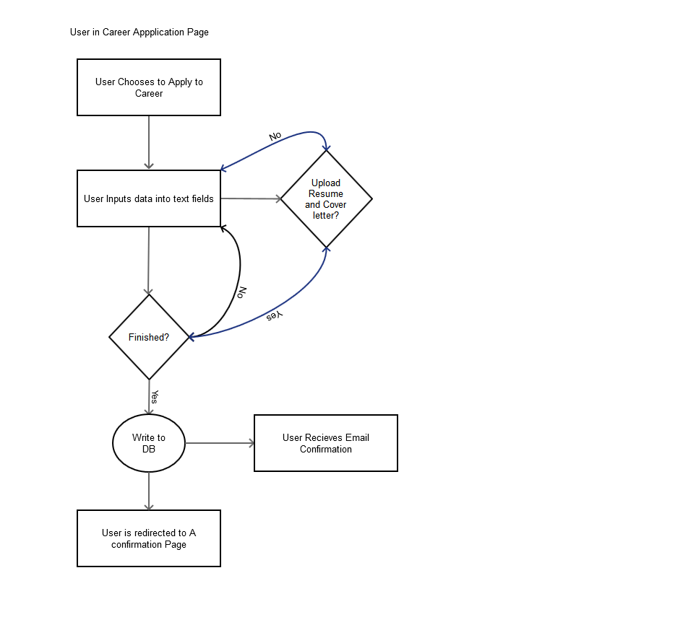

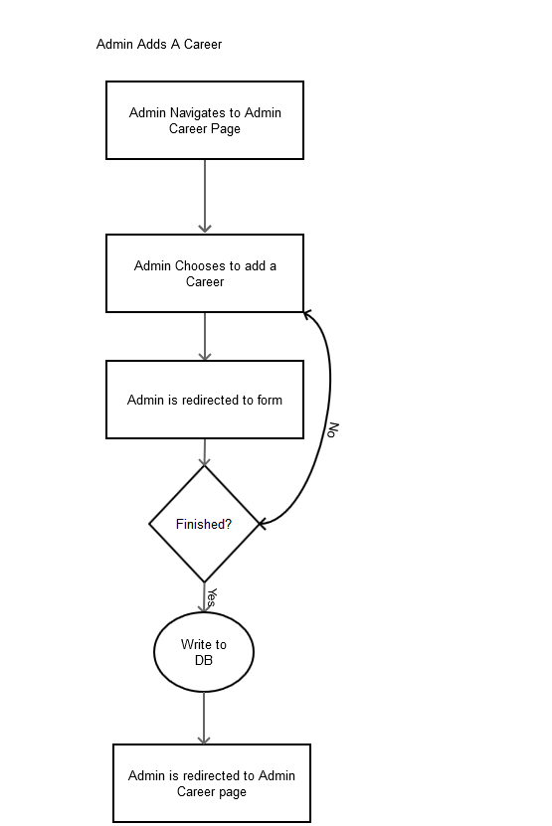

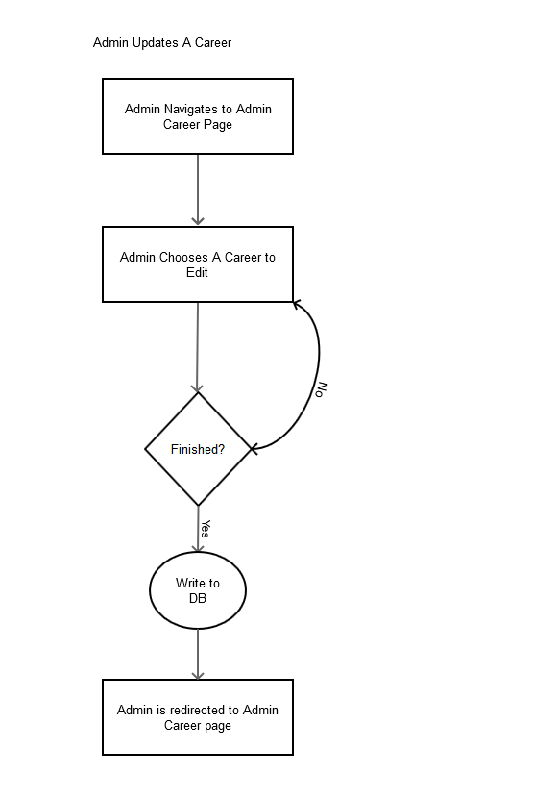

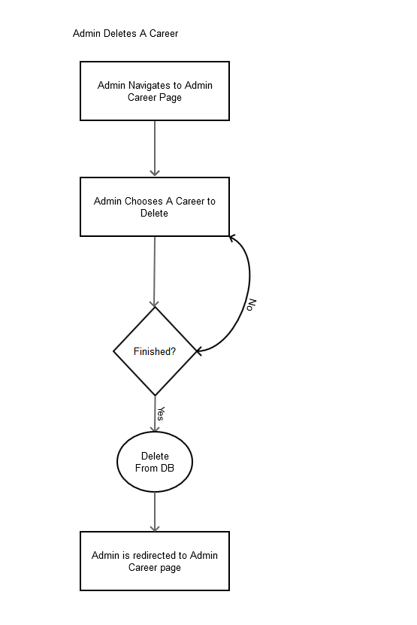

**Wireframes**

Public Pages

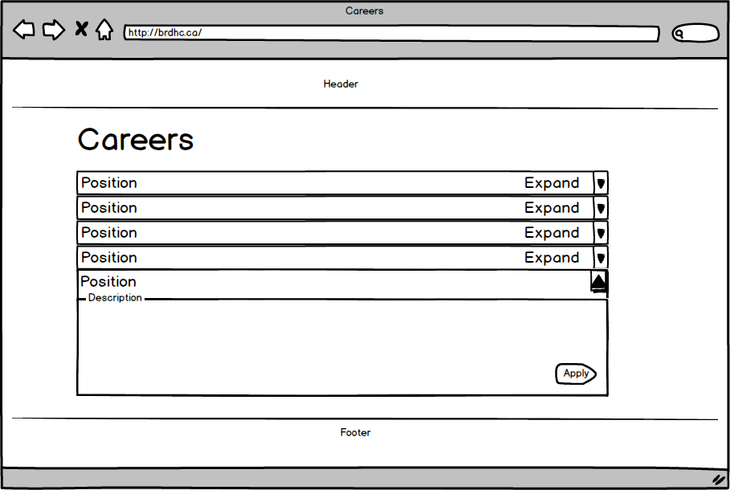

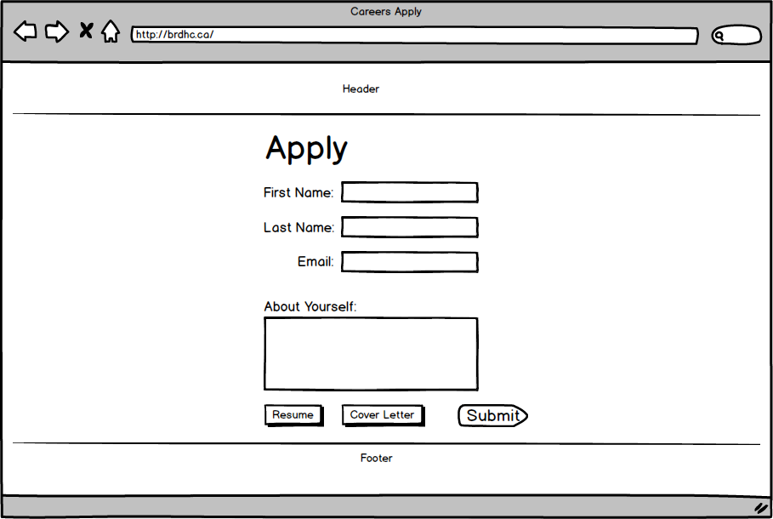

**Admin Pages**

